

**Green University of Bangladesh**

**Department of Computer Science and Engineering (CSE)**

**Semester: (Spring, Year:2024), B.Sc. in CSE (Day)**

**Lab Report NO #03**

**Course Title: Database System Lab**

**Course Code: CSE 210 Section: 221 D1**

**Lab Experiment Name: Modifying MySQL database and updating data in MySQL table.**

**Student Details**

| **Name** | | **ID** |
| --- | --- | --- |
| **1.** | Tanvir Ahmed | 221002461 |

**Lab Date : 18/3/2024**

**Submission Date : 25/3/2024**

**Course Teacher’s Name : Dr. Faiz Al Faisal**

| **Lab Report Status**  **Marks: ………………………………… Signature:.....................**  **Comments:.............................................. Date:..............................** |
| --- |

**1. TITLE OF THE LAB REPORT EXPERIMENT**

Modifying MySQL database and updating data in MySQL table.

**2. OBJECTIVES/AIM**

* To create a database
* To create tables in the database
* To declare the primary key
* To implement foreign key constraint
* To insert data into each table
* Add extra column
* Change the column name
* Show the outputs of change.

**3. PROCEDURE**

1. At first, we created a database named bank.
2. Then create some tables based on the lab exercise problem.
3. Now insert data on each table.
4. Add a new column to the table named customer.
5. Update the value of the new column.
6. Change the column name customer_city to city.
7. Change the datatype of the assets column.
8. Show the outputs of each change.

**4. IMPLEMENTATION**

Source Code:

1. Creating a Database:

CREATE DATABASE bank;

1. Creating Tables:

#CREATE DATABASE bank;

USE bank;

#CREATE TABLE branch (branch_name varchar(13), branch_city varchar(13), assets int not null);

#ALTER TABLE branch CHANGE COLUMN branch_name branch_name varchar(13) not null;

#CREATE TABLE customer (customer_id int not null, customer_name varchar(13) not null, customer_city varchar(13), PRIMARY KEY(customer_id));

#CREATE TABLE account (account_number int not null, branch_name varchar(13) not null, balance int not null, PRIMARY KEY (account_number), FOREIGN KEY branch_name REFERENCES branch(branch_name));

#CREATE TABLE loan (loan_number int not null, branch_name varchar(13) not null, amount int not null, PRIMARY KEY (loan_number), FOREIGN KEY(branch_name) REFERENCES branch(branch_name));

#CREATE TABLE deposite (customer_name varchar(13), account_number varchar(13), FOREIGN KEY(customer_name) REFERENCES customer(customer_name), FOREIGN KEY (account_number) REFERENCES account(account_number));

#CREATE TABLE borrower (customer_name varchar(13), loan_number varchar(13), FOREIGN KEY (customer_name) REFERENCES customer(customer_name), FOREIGN KEY (loan_number) REFERENCES loan(loan_number));

1. Inserting data on the tables:

use bank;

#INSERT INTO branch VALUES("Sonali Bank","Dhaka",1000000000);

#INSERT INTO customer VALUES(1, "Tanvir Ahmed", "Dhaka");

#INSERT INTO account VALUES(1,"Sonali Bank", 10000);

#INSERT INTO loan VALUES(1, "Sonali Bank", 10000);

#INSERT INTO deposite VALUES ("Tanvir Ahmed", 1);

#INSERT INTO borrower VALUES ("Tanvir Ahmed", 1);

1. Adding a new column in the customer table:

use bank;

ALTER TABLE customer ADD COLUMN email varchar(100) AFTER customer_city;

1. Set a value to the new column.

use bank;

UPDATE customer set email="tanvir@gmail.com" WHERE customer_id=1;

1. Changing the column name of customer_city to city:

use bank;

ALTER TABLE customer CHANGE COLUMN customer_city city varchar(13);

1. Changing the datatype of the assets column.

use bank;

ALTER TABLE branch CHANGE COLUMN assets assets bigint not null;

**5. TEST RESULT / OUTPUT**

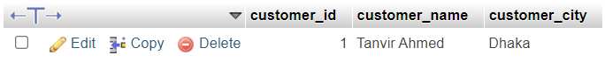

fig1. Customer table before adding email column.

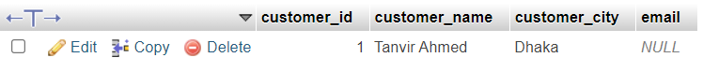

fig2. Customer table after adding email column.



Fig3. Customer table after updating email value

fig4. Before changing the column name customer_city.



.fig5. After changing the column name.

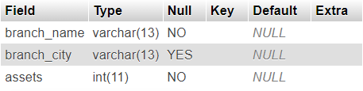

Fig6. Before modifying the datatype of the assets column.

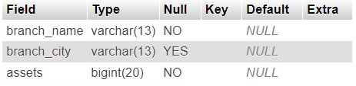

Fig7. After changing the datatype of the assets column.

**6. ANALYSIS AND DISCUSSION**

* In this exercise, at first, the database called ‘bank’ was successfully created.
* Then we created some tables based on the lab exercise given in the lab manual.
* We insert information into each table using INSERT INTO statements.
* Changing on tables using ALTER TABLE statements that are given exercise in the lab manual.
* Showing all the changes that I made based on the exercise.
* I googled a piece of information on what would be the alternating datatype of int datatype.
* I found that bigint is a datatype that can store more data than int datatype.

**7. SUMMARY**

This lab exercise demonstrates practical applications of SQL commands especially to use of ALTER TABLE command that I learned from the previous class. I implemented the exercise by creating a database, and tables, inserting data into each table, and modifying columns based on the exercise. The output comes perfectly.